**Name:** Kunal Gola

**Batch:** Dec 2022

**Project:** Historical Places of India (Mini Project)

**Minor Project GitHub Link:**

<https://github.com/Gola-k/WD-MINOR-DECEMBER>

**Minor Project Embedded:**



Step 1: html file is created and applied stylings to <body>, <header> tag and <icon> tag in the header.

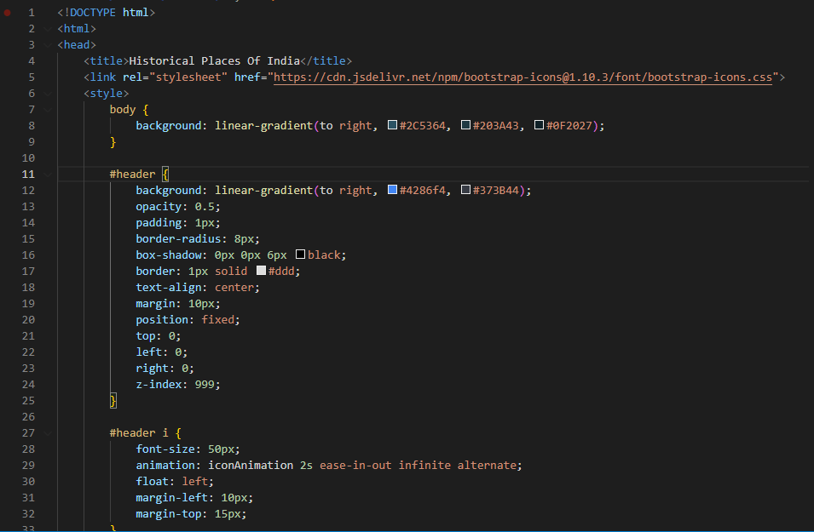

Step 2: Stylings are added to header text <h1> tag and animations are added to it, then stylings are added to grid container.

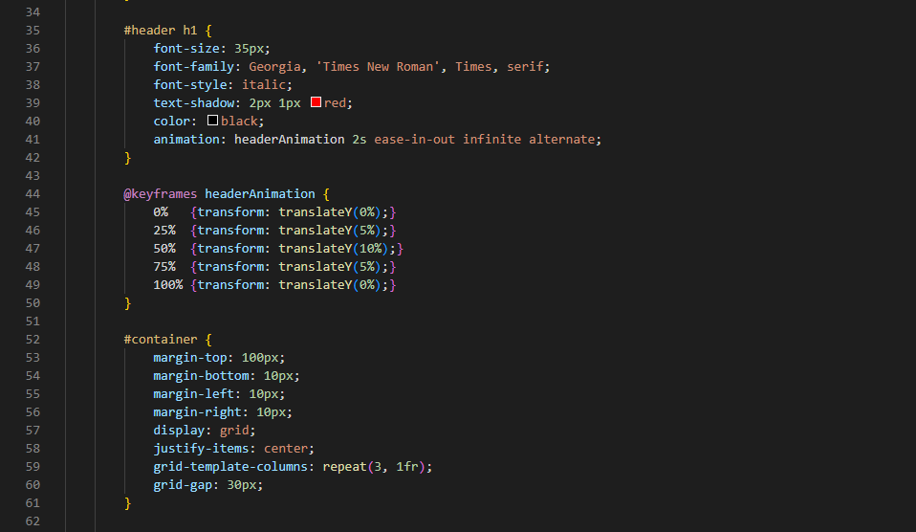

Step 3: Stylings are added to each grid item and the images in it. Stylings are added to both <audio> and <footer> tag.

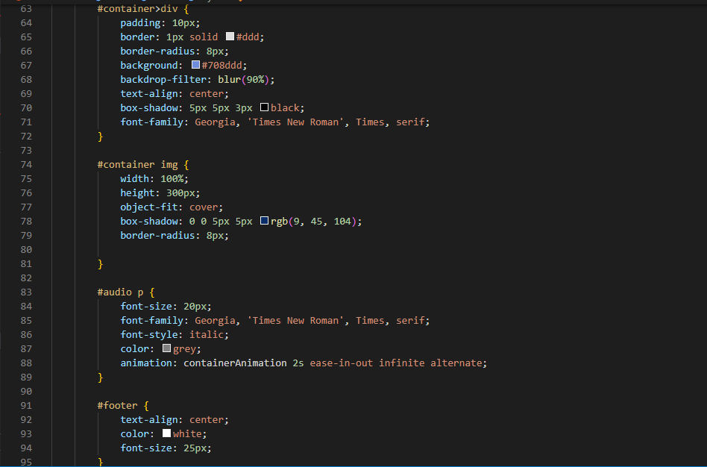

Step 4: <body> tag is started, header is created, each grid container with an image and a link to its Wikipedia website is attached to it and a brief description is mentioned below the images of Historical Monuments of India.

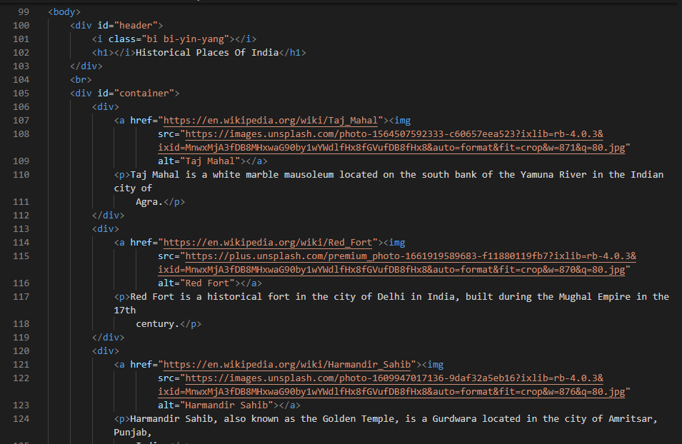

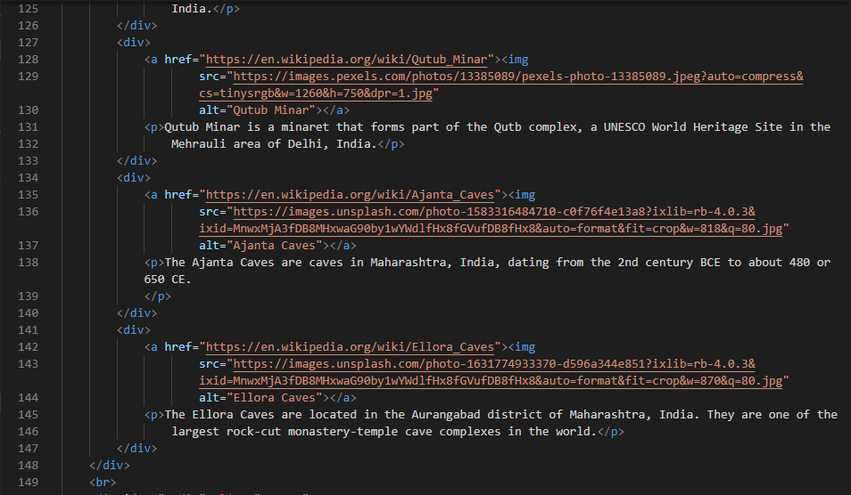

Step 5: An audio player is embedded for playing an audio file and a footer is added “Designed and Developed by Kunal Gola”. The body and html tag are closed.

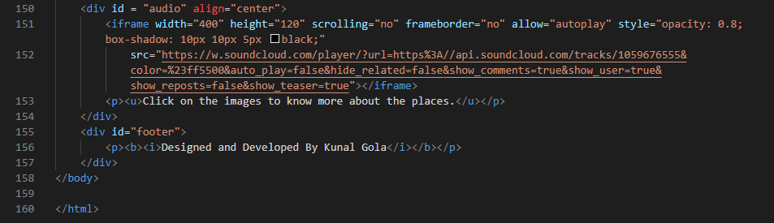

**Screenshots of the project website**

